  

**NAME : ZOHO BOOKS**

**PROJECT TITLE : ZOHO BOOKS FOR KEERTHI**

**SWEETS**

**PROJECT SUBMITTED : SMART INTERNZ**

**YEAR : III**

**DEPARTMENT : COMMERCE & CA**

**SEMESTER : V**

**GROUP ID : NM2023TMID10022**

**MEMBERS OF THE GROUP : J.NITHIYAL**

**U.VARSHINI**

**M.JEGENESH**

**S.KARASAKAN**

**GUIDED BY : Dr.R.RAMPRABU**

**SPOC NAME : EZHILVENDHAN R**

**PREPARATION MAINTANCE OF ZOHO BOOKS FOR KEERTHI SWEETS**

**STEP 1**

CREATED A COMPANY

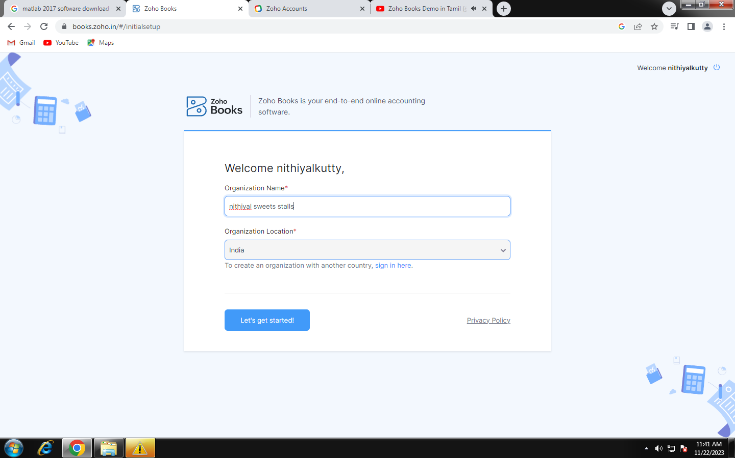

CLICK ON THE GET STARTED BUTTON

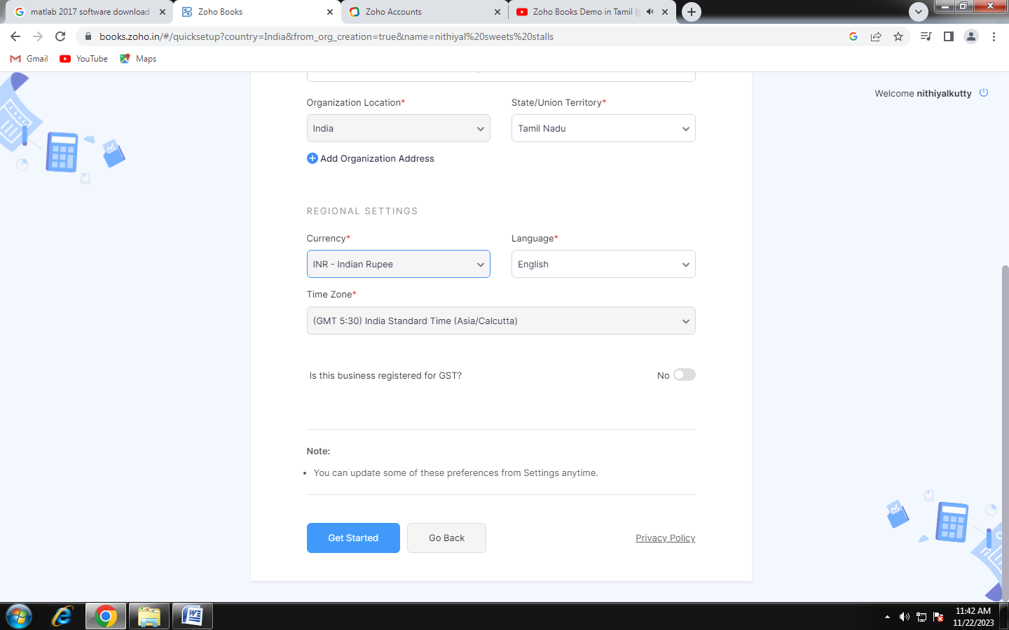

WELCOME TO NITHIYAL SWEETS COMPANY

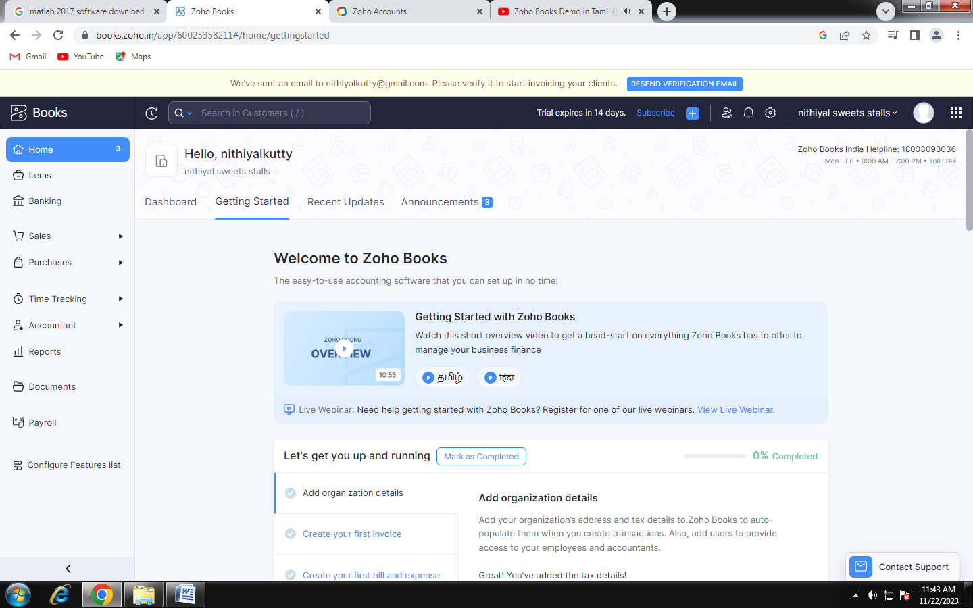

CREATED A ITEMS

